**Experiment 21**

**AIM :**

To design DFA AB over end using automata softaware.

**Design and output:**

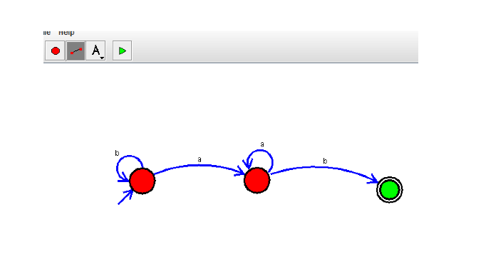

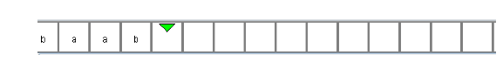

**Result:** Thus designing DFA AB over end is done and verified by giving sample inputs.